Data Sheet

Swallow Incubators

Features

- Process and delayed start timers
- Multi-Program
- Fan-Circulated
- Stainless steel radiused interior
- Adjustable shelf positions
- Auto-recovery options
- Class 2 over temperature protection

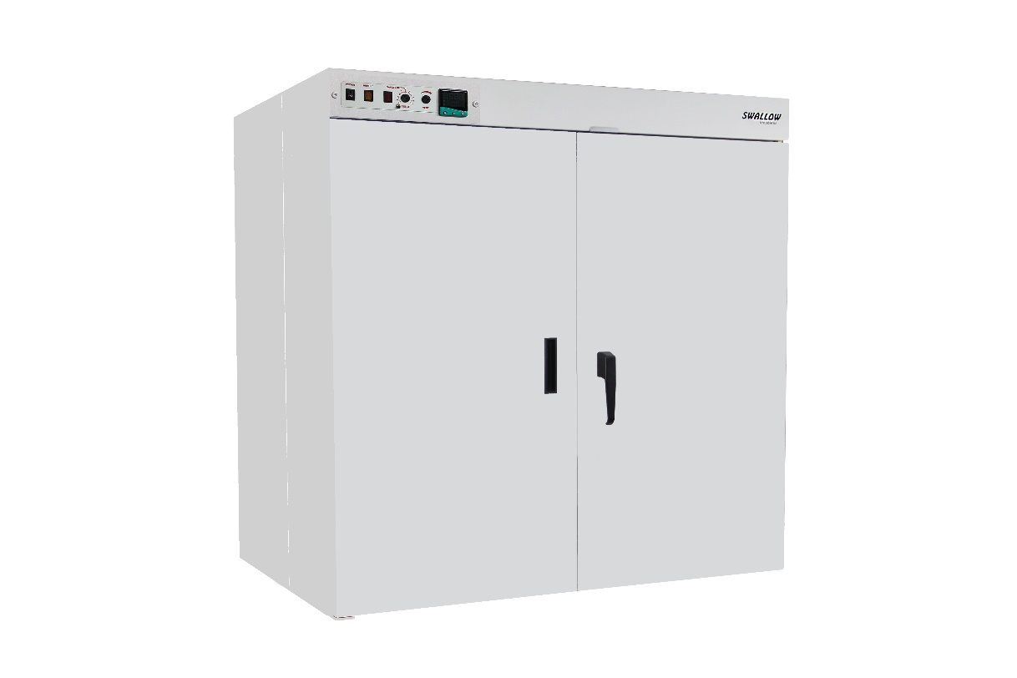

Cat. No. | LI/SWL/20/1 | LI/SWL/42/1 | LI/SWL/50/1
Capacity (litres) | 480 | 750 | 1000
Shelves Included | 3 | 3 | 3
Temp. Range, ˚C | 5 above ambient to 80 | 5 above ambient to 80 | 5 above ambient to 80
Internal Dims, HWD mm | 1000 x 720 x 670 | 1000 x 1120 x 670 | 1270 x 1120 x 700
External Dims, HWD mm | 1270 x 870 x 865 | 1270 x 1270 x 865 | 1655 x 1270 x 1025

The above is the standard specification. Any modification/deviation for the above will be clearly identified on the quotation front sheet

